Name: ______________________ Date: _________________ Period: ____
Economics K.I.M. Vocabulary Chart
Example
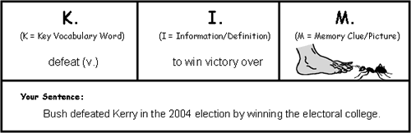
K  Key Word | I  Information (Definition) | M  Memory Cue  (Picture or sentence)
Market Economy
Traditional Economy
Command Economy
Mixed Economy
scarcity
Goods
Services
Tariff
Embargo
Quota

