Map of Europe
Name ________________________
Date ______________ Class _____

- Remember to write small & neatly!
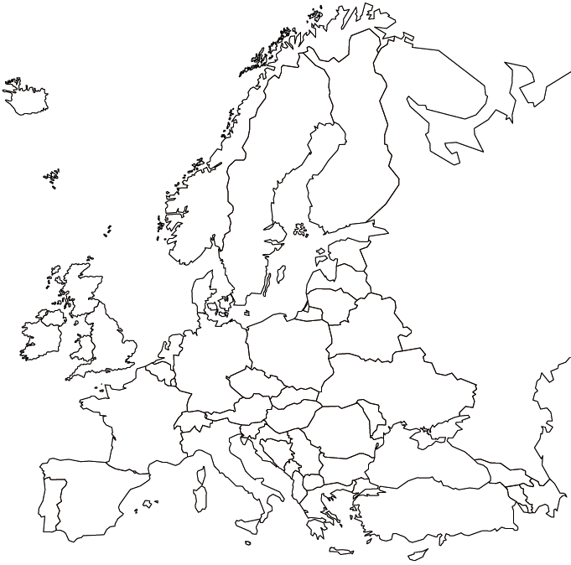
- Label all 9 countries.
- Label all 10 physical features.
- Count to be sure you have 19 labels.

Standard: SS6G7b
_____Belgium
_____France
_____Germany
_____Italy
_____Poland
_____Russia
_____Spain
_____Ukraine
_____United Kingdom

Standard: SS6G7a
_____Danube River
_____Rhine River
_____English Channel
_____Mediterranean Sea
_____European Plain
_____Alps
_____Pyrenees
_____Ural Mountains
_____Iberian Peninsula
_____Scandinavian Peninsula

